THE GARDEN
A PROJECT REPORT

Submitted by

JOEL JOJU [SCM23MCA-2020]

to

The APJ Abdul Kalam Technological University
in partial fulfillment of the requirements for the award of the Degree of
Master of Computer Application



Department of Computer Science and Engineering

SCMS SCHOOL OF ENGINEERING AND TECHNOLOGY
(Affiliated to APJ Abdul Kalam Technological University) VIDYA NAGAR, PALISSERY, KARUKUTTY ERNAKULAM - 683582

November 2024

DEPARTMENT OF COMPUTER SCIENCE AND ENGINEERING SCMS SCHOOL OF ENGINEERING AND TECHNOLOGY
(Affiliated to APJ Abdul Kalam Technological University) VIDYA NAGAR, PALISSERY, KARUKUTTY ERNAKULAM - 683582



CERTIFICATE

This is to certify that the report entitled ‘THE GARDEN’ submitted by JOEL JOJU to the APJ Abdul Kalam Technological University in partial fulfillment of the requirements for the award of the Degree of Master of Computer Application is a bonafide record of the project work carried out by him/her under my guidance and supervision.

Project Guide | Project Coordinator | Head of the Department
Ms. Deepa Johny  Assistant Professor  Department of Computer  Science and Engineering | Ms. Greshma P Sebastian  Assistant Professor  Department of Computer  Science and Engineering | Dr. Manish T I  Professor  Department of Computer  Science and Engineering

ACKNOWLEDGEMENT

I am greatly indebted to Dr. Anitha G Pillai, Principal, SSET, Ernakulam and Dr. Manish T I, Head of department, Department of Computer Science and Engineering, SSET, who whole heartedly granted me the permission to do the project.

I would like to thank my guide, Ms. Deepa Johny, and project coordinator, Ms. Greshma P Sebastian, Department of Computer Science and Engineering, SSET who has given me valuable guidance and support all the way.

I would like to express my sincere gratitude to all the teachers of Computer Science Department who gave me moral and technical support. I would like to thank the supporting staff in the Computer lab whose dedicated work kept the lab working smoothly, thus enabling me to have access to various resources which helped me understand more about the project topic. I would also like to thank friends and family members for providing me with necessary resources and support. Last but not the least, I would like to thank God Almighty for helping me to do my project hassle free.

ABSTRACT

This project is an e-commerce platform named "The Garden" designed to facilitate the online sale of plants . Developed using PHP, MySQL, HTML, CSS, and JavaScript, the website offers a user-friendly experience for customers to browse, search, and purchase a wide variety of products. The platform includes essential features such as user authentication, product management, a shopping cart, and a secure checkout process. An admin dashboard allows for efficient product management. The project aims to enhance accessibility and streamline the shopping experience for gardening enthusiasts, providing a convenient digital solution for both users and administrators.

TABLE OF CONTENTS

CONTENTS Page no.

Acknowledgement …………………………………………………………………ii
Abstract……………………………………………………………………………..iii
- Introduction
1.1 Project Overview………………………………………………………………1
1.2 Objective of the Project………………………………………………………..1
1.3 Scope of the Project……………………………………………………………2
1.4 Technologies Used…………….…………………………………………..…..3
- System Analysis
2.1 Problem Definition…………………………………………………………….4
2.2 Feasibility Study……………………………………………………………….4
2.2.1 Technical Feasibility…………………………………………………….5
2.2.2 Operational Feasibility…………………………………………………..5
2.3 Existing System………………………………………………………………..5
2.4 Proposed System………………………………………………………………6
- System Design
3.1 Data Flow Diagrams (DFD)…………………………………………………..7
3.1.1 Level 0 DFD…………………………………………………………….7
3.1.2 Level 1 DFD…………………………………………………………….7
3.1.3 Level 2 DFD ……………………………………………………………8
- Database Design
4.1 Table Design………………………………………………………………..11
4.1.1 Table Structure (Schema)…………………………………………….11
4.1.2 Keys (Primary, Index)………………………………………………..13
4.2 Entity-Relationship (ER) Diagram…………………………………………15
- Front-End Design
5.1 Front-end Technologies Used………………………………………...…….16
5.2 Forms and Input Validation………………………………………………..17
5.3 Screenshots of Key Screens………………………………………………..18
- Back-End Design
6.1 Database Management system used………………………………………..24
6.2 Server Environment………………………………………………………..24
6.3 Frameworks………………………………………………………………...24
- System Implementation
7.1 IDEs…………………………………………………………………...……25
7.2 Version Control System (e.g. Git)………………………………………….25
- Testing and Validation
8.1 Unit Testing………………………………………………………………...26
8.2 Integration Testing………………………………………………………….27
8.3 System Testing…………………………………….………………………..28
- Conclusion
9.1 Summary of Work………………………………………………………….29
9.2 Future Scope………………………………………………………………..29
- References……………………………………………………………………...30

LIST OF TABLES
No. | Title | Page No
4.1 | User Registration Table | 11
4.2 | Products Table | 12
4.3 | Order Table | 12
4.4 | Cart Table | 13

LIST OF FIGURES
No. | Title | Page No
3.1 | DFD Level 0 | 7
3.2 | DFD Level 1 - Admin & Customers | 7
3.3 | DFD Level 2 - Customer -order | 8
3.4 | DFD Level 2 - Customer - Profile | 9
3.5 | DFD Level 2 - Admin - Product | 9
3.6 | DFD Level 2 - Customer - Cart | 10
4.1 | ER Diagram | 15
5.1 | Registration Form | 17
5.2 | Login Form | 17
5.3 | Home Screen | 18
5.4 | Product Page | 19
5.5 | Contact Page | 19
5.6 | Cart Page | 20
5.7 | Checkout Page | 21
5.8 | Order Page | 21
5.9 | User account Page | 22
5.10 | Signout Page | 22
5.11 | Admin Dashboard Page | 23
5.12 | Add product Page | 23

CHAPTER-1

INTRODUCTION
  - PROJECT OVERVIEW

"The Garden" is an online shopping platform designed for selling plants. It features a responsive user interface where customers can easily browse products, search for specific items, add them to a cart, and complete their purchases through a secure checkout process. The project is built using PHP, MySQL, HTML, CSS, and JavaScript, ensuring dynamic content management and seamless user interactions.
Key features include:
- User Registration and Login: Secure user authentication for access to personalized features.
- Product Management: Admin functionality for adding, updating, and deleting products.
- Shopping Cart: Real-time cart management for users to review and update their selections before checkout.
- Admin Dashboard: A comprehensive interface for managing products efficiently.
The platform aims to provide a convenient and accessible way for customers to shop for gardening products while enabling streamlined management for the business owner.
  - OBJECTIVE OF THE PROJECT
The objective of "The Garden" is to create an efficient and user-friendly e-commerce platform for selling a wide variety of plants. This project aims to provide an accessible online marketplace where plant enthusiasts can easily browse, select, and purchase their desired plants. The platform features a comprehensive product page, user accounts for personalized experiences, and a streamlined checkout process. By integrating features like a shopping cart, order management, and a secure payment gateway, the project seeks to enhance user convenience and satisfaction, facilitating a seamless online shopping experience for plant lovers.
  - SCOPE OF THE PROJECT
The scope of "The Garden" project is to create a user-friendly e-commerce platform specifically for plant lovers. This online store focuses on offering a variety of plants, including indoor, outdoor, and decorative options, aimed at making plant shopping accessible and convenient. The platform allows customers to browse products, view detailed descriptions, add items to their cart, and complete purchases through a streamlined checkout process.
Key features include a product catalog with search option, a shopping cart system for managing selected items, and a secure checkout experience with multiple payment options. The user account section enables customers to view and update their personal information, enhancing the shopping experience.
On the administrative side, the project provides an efficient dashboard for managing the product inventory. Administrators can add, update, and delete products, ensuring the catalog remains current. The admin panel focuses on ease of use, providing a clear overview of all products, including their details and availability.
Overall, the project aims to deliver a reliable and engaging online platform for plant sales, catering to both customers looking for an easy plant shopping experience and administrators needing efficient inventory management tools.
  - TECHNOLOGIES USED
The project primarily utilizes PHP, MySQL, JavaScript, CSS, and HTML to build the core functionality and design of the website. PHP is used for server-side scripting, handling user authentication, data processing, and integrating with the MySQL database to store user and product information. MySQL is the database management system that stores data such as user accounts, product details, orders, and cart information. JavaScript is employed for client-side interactivity, ensuring dynamic updates on the product pages, user interface adjustments, and enhancing user experience with features like the cart and checkout. CSS is used for styling the front-end, ensuring a visually appealing and responsive design. HTML forms the backbone of the page structure, creating the layout of the website. Additionally, AJAX and JSON are utilized for asynchronous data loading and seamless communication between the client-side and server-side, allowing for real-time updates on the page without requiring full reloads.

CHAPTER-2
SYSTEM ANALYSIS
2.1 PROBLEM DEFINITION
With the increasing popularity of online shopping, plant enthusiasts and potential customers often struggle to find a dedicated and user-friendly platform that caters specifically to their needs. Traditional physical stores have limited availability, and existing general e-commerce platforms do not provide specialized features for selling plants. This leads to a lack of information about plant care, limited product variety, and difficulty in making informed purchasing decisions. Additionally, managing inventory, tracking orders, and handling customer queries can be challenging without an integrated solution.
The project aims to address these issues by creating a comprehensive e-commerce platform, The Garden, focused solely on selling a wide variety of plants. This platform will streamline the process for customers to browse, search, and purchase plants from the comfort of their homes. By implementing a structured and interactive website, the project will enhance the user experience, provide detailed product information, and facilitate smooth transactions. For administrators, the system will offer tools for product management, inventory control, and customer data handling, thereby simplifying operations and improving service delivery.
2.2 FEASIBILITY STUDY
The feasibility study for the Garden project assesses its practicality across several dimensions: technical and operational.
2.2.1 TECHNICAL FEASIBILITY
The technical feasibility of The Garden project is highly promising as it utilizes widely-supported and well-established technologies. The project is built using PHP for server-side processing, MySQL for database management, and JavaScript for dynamic functionalities on the client side. HTML and CSS are employed to structure and style the website. These technologies are reliable, scalable, and have extensive community support, ensuring that the development, maintenance, and troubleshooting of the platform will be straightforward. Additionally, the decision to use these technologies reduces the need for costly third-party tools or libraries, making the project technically feasible and sustainable.
2.2.2 OPERATIONAL FEASIBILITY
Operationally, The Garden is designed to provide a seamless and user-friendly experience for both customers and administrators. The website includes basic e-commerce functionalities such as product display, cart management, and order placement, which are essential for the day-to-day operations of an online plant store. The admin dashboard allows for easy management of product listings and facilitating smooth site administration. Since the system is straightforward with minimal complexity, the operations can be efficiently managed by a small team or even by a single person with basic technical expertise. The operational process is simple, ensuring that employees can easily manage updates, address customer issues, and handle orders, contributing to the overall operational feasibility of the platform.
2.3 EXISTING SYSTEM
In the traditional plant retail market, customers often rely on physical stores to purchase plants. This approach has several limitations, such as a restricted variety of plants due to space constraints, lack of detailed information about plant care, and the inconvenience of visiting multiple stores to find specific plant species. Some businesses may have basic online listings, but these usually lack comprehensive features like real-time stock updates, user accounts, and an intuitive user interface for browsing products and making purchases. Additionally, existing online platforms may not offer user-friendly features like easy cart management, streamlined checkout processes, or detailed product descriptions, making it difficult for users to make informed buying decisions.
2.4 PROPOSED SYSTEM
The proposed system, The Garden, aims to overcome these limitations by providing a fully-featured e-commerce platform dedicated to selling a wide variety of plants. This system offers an organized, user-friendly interface for browsing, searching, and purchasing plants online. It includes essential features such as user registration, login, product search, detailed product descriptions, an add-to-cart function, and a secure checkout process. The platform is designed to enhance the shopping experience by providing users with access to a broader range of plants and detailed information about each product, helping customers make well-informed decisions. The integration of a responsive design ensures that users can access the platform seamlessly on different devices, offering a more convenient and accessible way to buy plants online.

CHAPTER 3
SYSTEM DESIGN
3.1 DATA FLOW DIAGRAMS (DFD)

3.1.1 Level 0 DFD
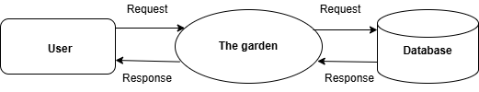
Figure 3.1
3.1.2 Level 1 DFD
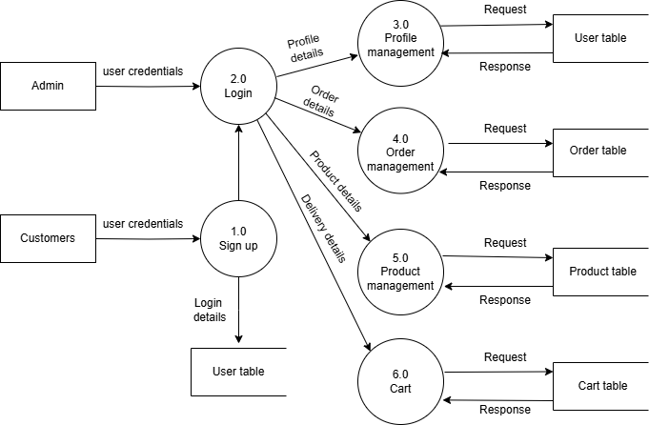
Figure 3.2 Level 1 admin and customers

3.1.3 Level 2 DFD
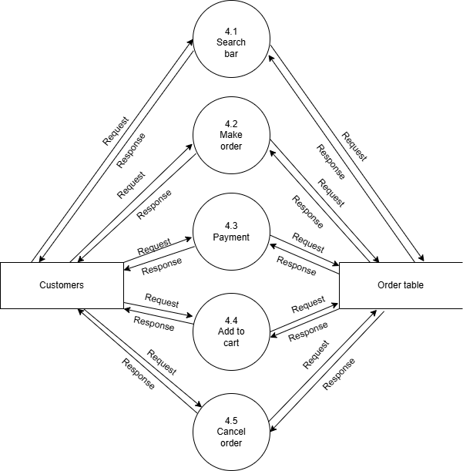

Figure 3.3 Level 2 Customer - order

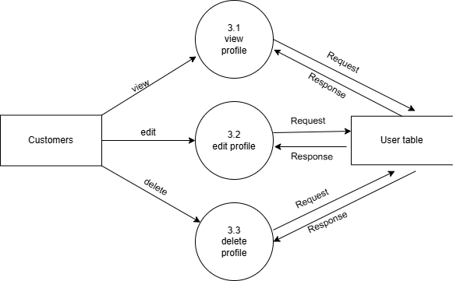
Figure 3.4 Level 2 Customer - profile
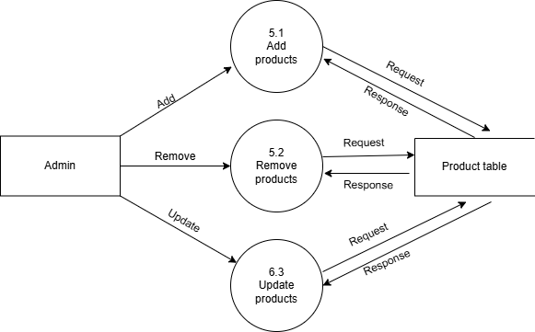
Figure 3.5 Level 2 Admin - product
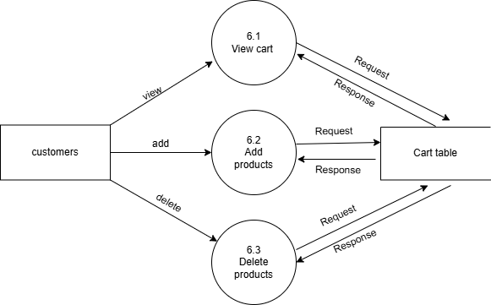
Figure 3.6 Level 2 Customer - cart

CHAPTER 4
DATABASE DESIGN
4.1 TABLE DESIGN
4.1.1 TABLE STRUCTURE (SCHEMA)
Table 4.1 User Registration Table
FIELD | DATATYPE | CONSTRAINTS | DESCRIPTION
id | int | Primary key | Id of user
Username | Varchar(225) | Not null | Name of user
Email | Varchar(225) | unique | Email of user
Password | Varchar(225) | Not null | Password of user
Role | Enum(user,admin) | Not null | User or admin
Created_at | timestamp | Not null | Created Date & time
Address | Varchar(255) | Not null | Address of user
phone | Int(10) | Not null | Number of user

Table 4.2 Products Table
FIELD | DATATYPE | CONSTRAINTS | DESCRIPTION
Id | Int | Primary key | Id of product
Name | Varchar(255) | Not null | Name of product
Price | Decimal(10,2) | Not null | Price of product
Description | Text | Not null | About the product
Image | Varchar(255) | Not null | Product image
Created_at | Timestamp | Not null | Created date & time

Table 4.3 Order Table
FIELD | DATATYPE | CONSTRAINTS | DESCRIPTION
Order_id | Int | Primary key | Id of order
User_id | Int | Index key | Id of user
Order_date | Timestamp | Not null | Date of the order
Total_price | Decimal(10,2) | Not null | Total price of order
Payment_method | Varchar(50) | Not null | Payment type
Address | Text | Not null | Address of user
Phone | Varchar(15) | Not null | Number of user

Table 4.4 Cart Table
FIELD | DATATYPE | CONSTRAINTS | DESCRIPTION
cart_id | Int | Primary key | Id of cart
user_id | Int | Index key | Id of user
product_id | Int | Index key | Id of product
quantity | Int | Not null | Product quantity
date_added | Timestamp | Not null | Created date & time

4.1.2 KEYS (PRIMARY, INDEX)
Keys are essential elements in database design that establish relationships between tables andensure data integrity. In the Garden project, both primary and index keys play significant roles:
- Primary key: In the garden project, primary keys play an essential role in ensuring the uniqueness and integrity of data across different tables. The users table utilizes id as its primary key, an auto-incrementing integer that uniquely identifies each registered user. This setup allows efficient management of user data, enabling the system to handle user-specific operations seamlessly. Similarly, the products table also employs id as its primary key, which uniquely distinguishes each product in the database. This auto-incrementing identifier simplifies product retrieval and management processes, making it easier to update or display product details on the website.For the cart table, the cart_id serves as the primary key. This column ensures that each cart entry is uniquely identified, allowing the system to efficiently track items added to the cart by users. This is especially important in e-commerce applications where multiple users may simultaneously interact with the cart system. In the orders table, the order_id acts as the primary key, providing a unique identifier for each order placed. This primary key structure facilitates order management, allowing the system to accurately retrieve, update, and display order information as needed.Overall, the use of primary keys across these tables enhances data integrity and performance. By preventing duplicate entries and ensuring that each record can be uniquely identified, primary keys play a vital role in maintaining the consistency and reliability of the database, ultimately contributing to a more efficient and scalable e-commerce platform.

- Index key: In the garden project, the use of index keys in the database plays a significant role in optimizing query performance and ensuring faster data retrieval. Index keys are utilized in various tables to enhance the efficiency of operations, particularly when searching, filtering, or joining large datasets.For instance, in the users table, an index can be applied on the email column. Since email addresses are frequently used to identify users during login and for account-related operations, indexing this column helps speed up searches and ensures quick access to user records. Similarly, in the products table, indexing the name or price columns can be beneficial when implementing search functionality on the product page or when users sort products by price. These indexed columns allow the database to quickly locate relevant products without scanning the entire table, significantly reducing response times.In the cart table, indexing can be applied to the user_id and product_id columns. This indexing approach facilitates efficient lookups when retrieving items added to a specific user's cart, especially when users interact with their carts frequently. Additionally, in the orders table, indexing on the user_id column is advantageous for tracking orders placed by users. It enables fast retrieval of order history, improving the performance of order-related queries and providing a better user experience.By utilizing index keys effectively, your project benefits from improved query execution times and enhanced overall database performance. The strategic application of indexes reduces the workload on the database engine, making it easier to handle complex queries and deliver a smooth experience on the front end, particularly as the volume of data grows over time.

4.2 Entity-Relationship (ER) Diagram

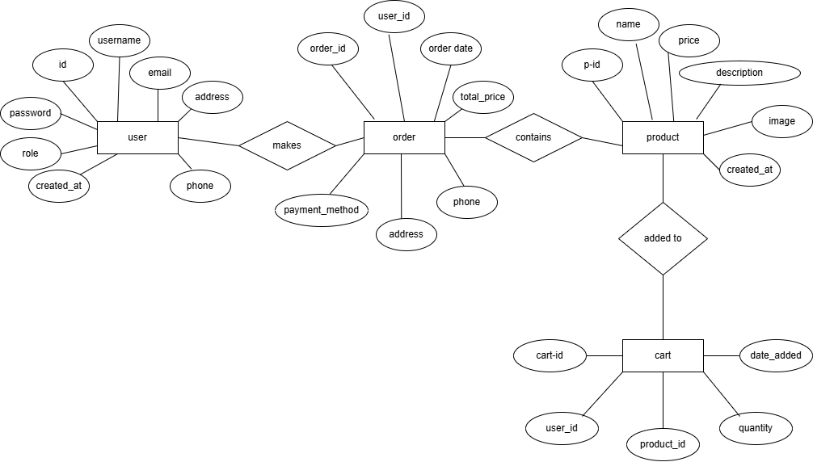

Figure 4.1 ER Diagram

CHAPTER-5
FRONT-END DESIGN
5.1 FRONT-END TECHNOLOGIES USED
In the garden project, the front-end technologies are crucial for creating an engaging and user-friendly interface. The core front-end technologies you have used include HTML, CSS, and JavaScript.
- HTML (HyperText Markup Language) forms the backbone of the website by providing its structure. It defines the layout of the various elements on the page, such as buttons, forms, and product listings. Each element, from headers to input fields, is crafted using HTML, ensuring the content is presented clearly to the user.
- CSS (Cascading Style Sheets) is used for styling and enhancing the visual appearance of the website. It manages the colour’s, fonts, spacing, and layout, making the website aesthetically pleasing and consistent. Through CSS, you have created responsive design elements, providing a smooth experience across different devices and screen sizes.
- JavaScript adds interactivity to the website, making it dynamic and responsive. It is used to handle various client-side operations, such as form validation, updating the cart without reloading the page, and displaying interactive elements like modals and alerts. JavaScript's role is vital in enhancing user experience by enabling real-time feedback and smoother navigation throughout the site.
Additionally, AJAX (Asynchronous JavaScript and XML) is used in certain parts of the project for asynchronous data loading. It allows the website to fetch data from the server without requiring a full page reload, making actions like updating the cart or saving user details seamless. JSON (JavaScript Object Notation) is employed for data exchange between the client and server, providing a lightweight format to transmit structured data efficiently. Together, these technologies create a robust and interactive front end for your e-commerce platform.

5.2 FORMS AND INPUT VALIDATION
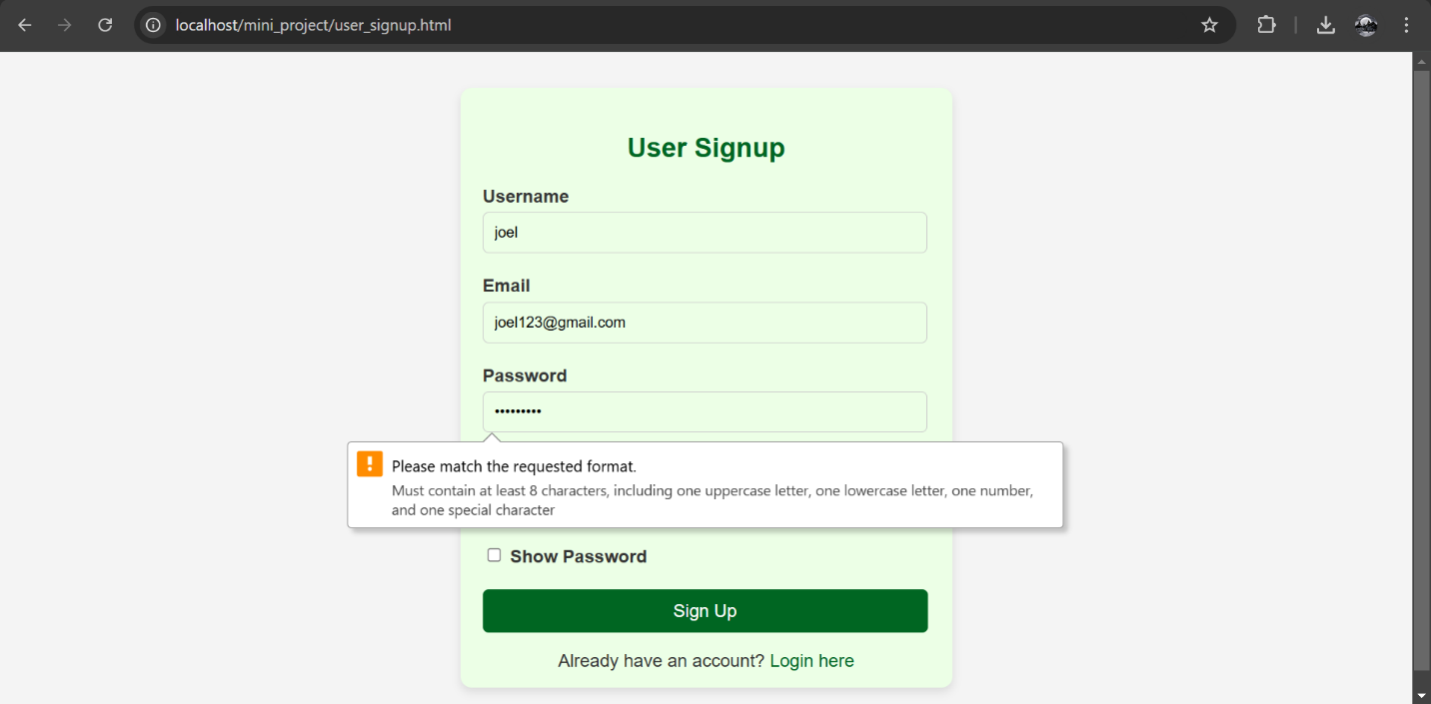
Figure 5.1 Registration Form
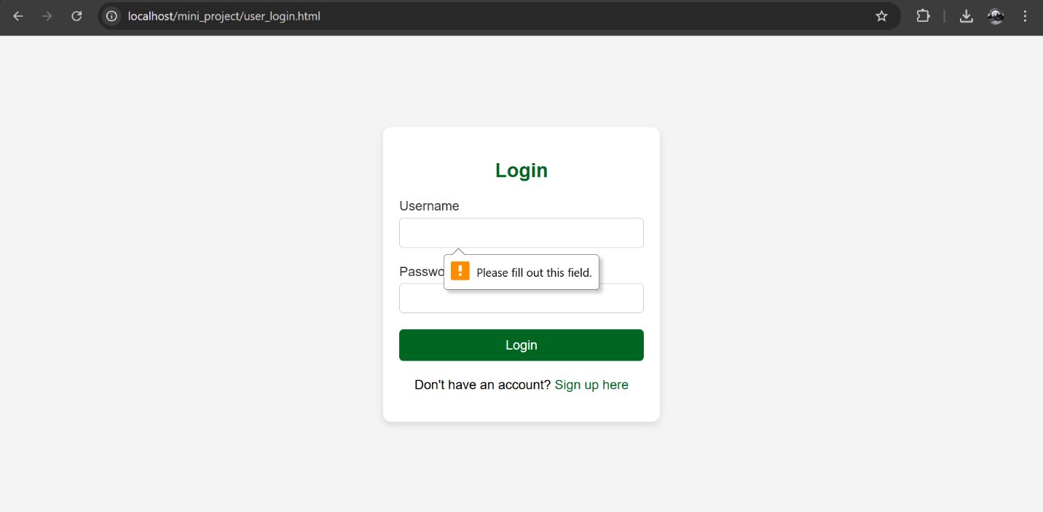
Figure 5.2 Login Form

5.3 SCREENSHOTS OF KEY SCREENS



Figure 5.3 Home Screen

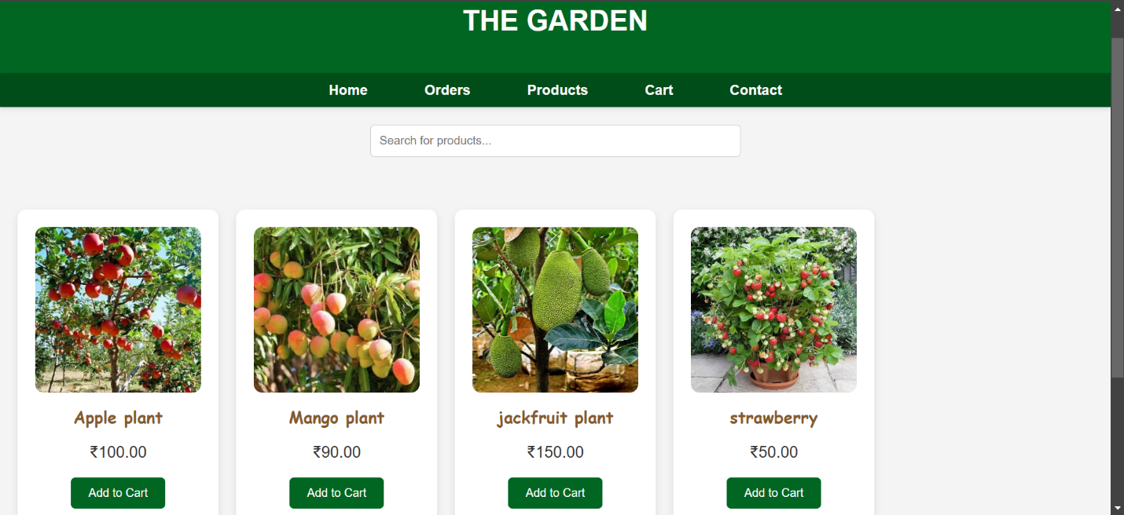
Figure 5.4 Product Page
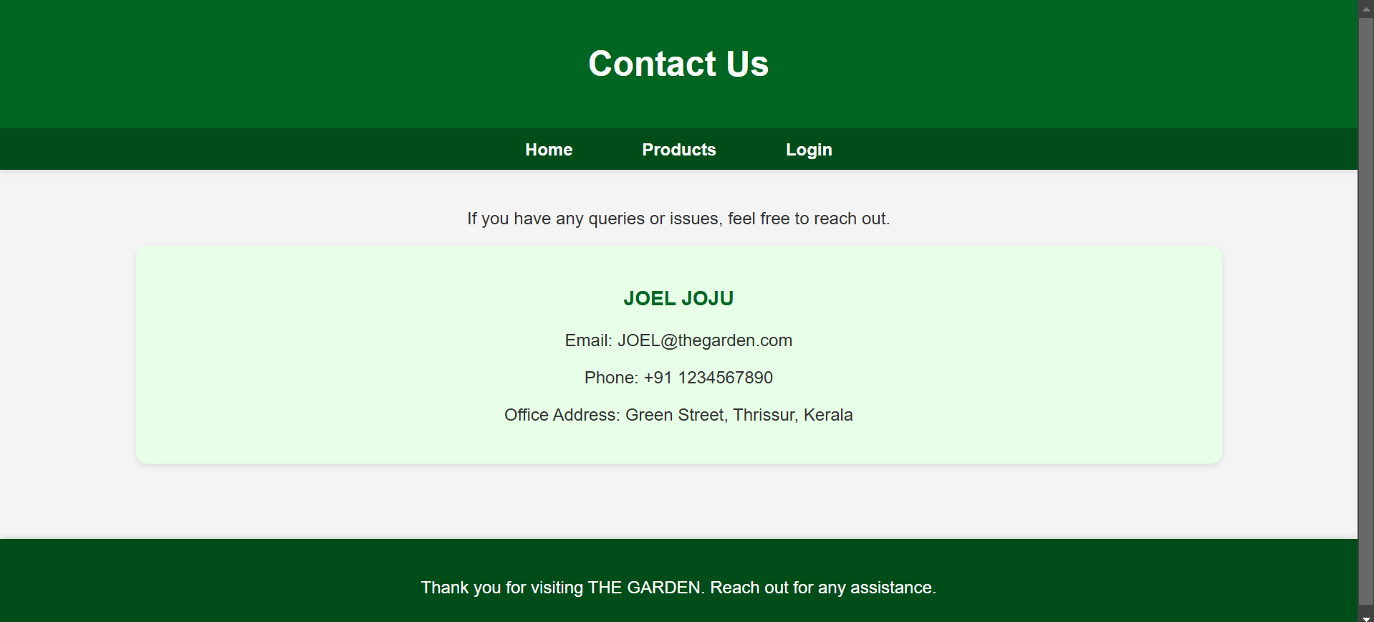
Figure 5.5 Contact Page

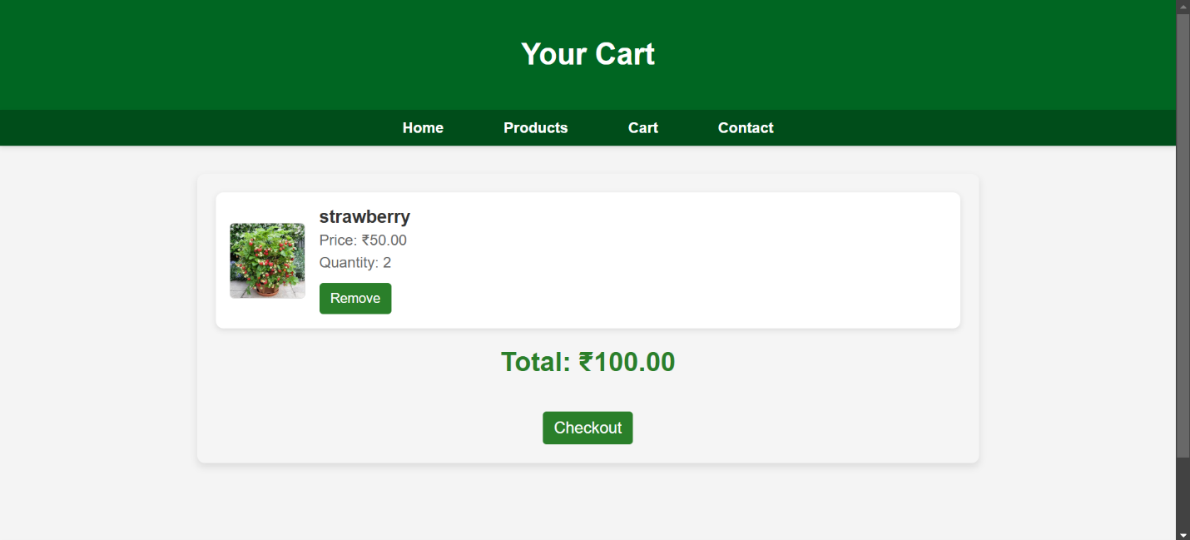
Figure 5.6 Cart Page
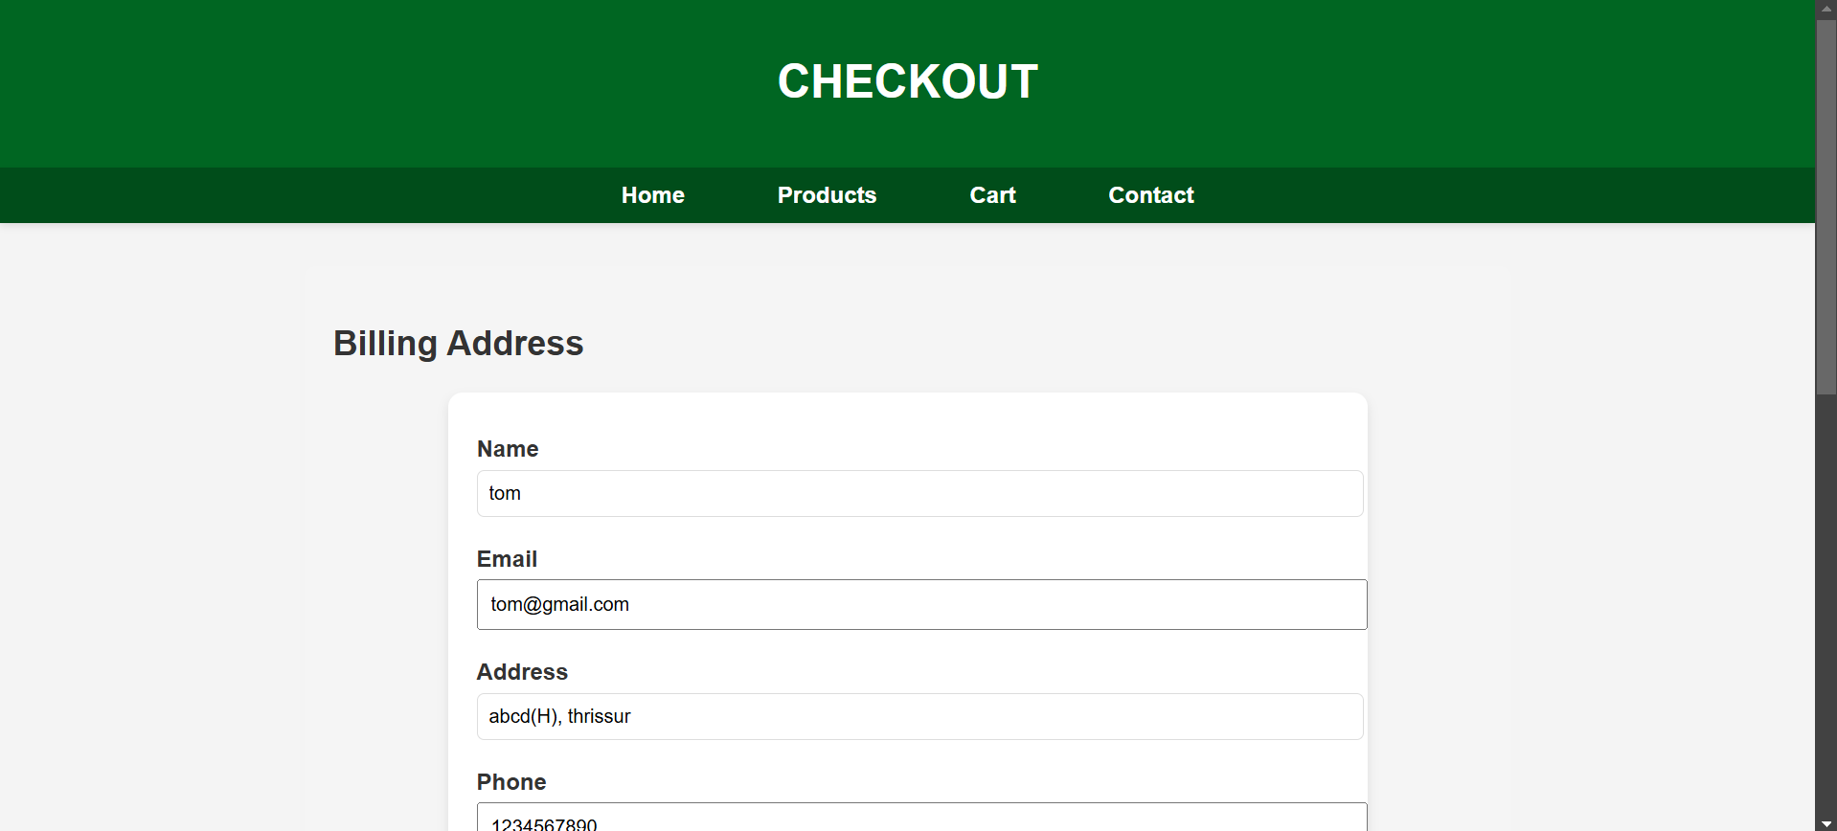

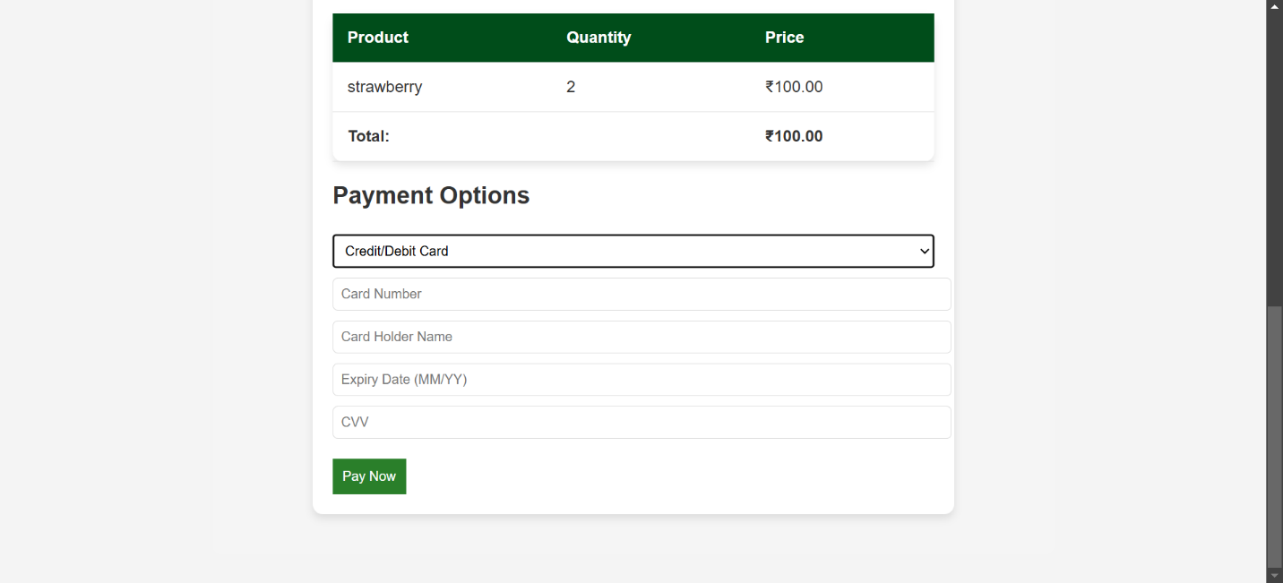
Figure 5.7 Checkout Page
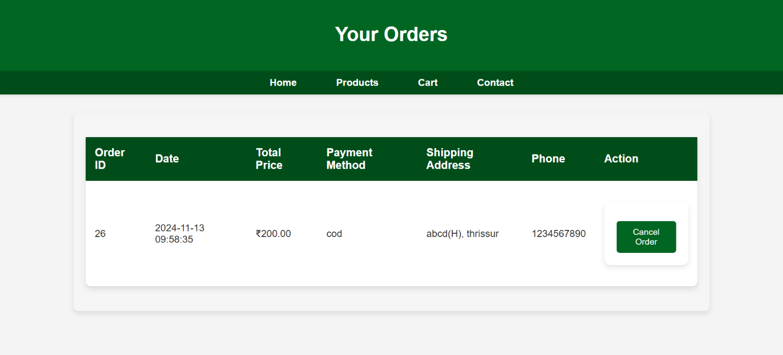
Figure 5.8 Order Page


Figure 5.9 User account Page

Figure 5.10 Signout Page

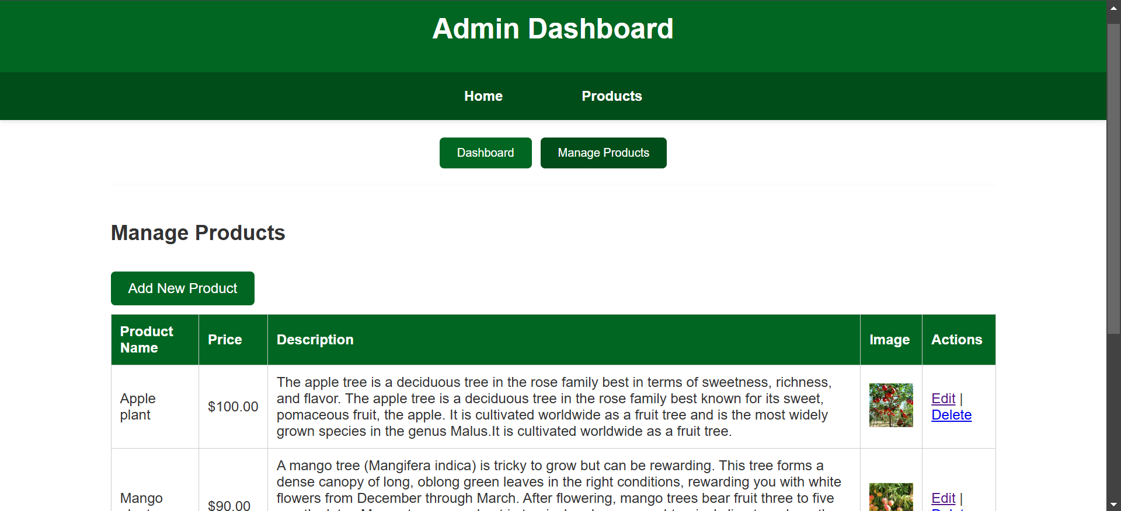
Figure 5.11 Admin Dashboard Page
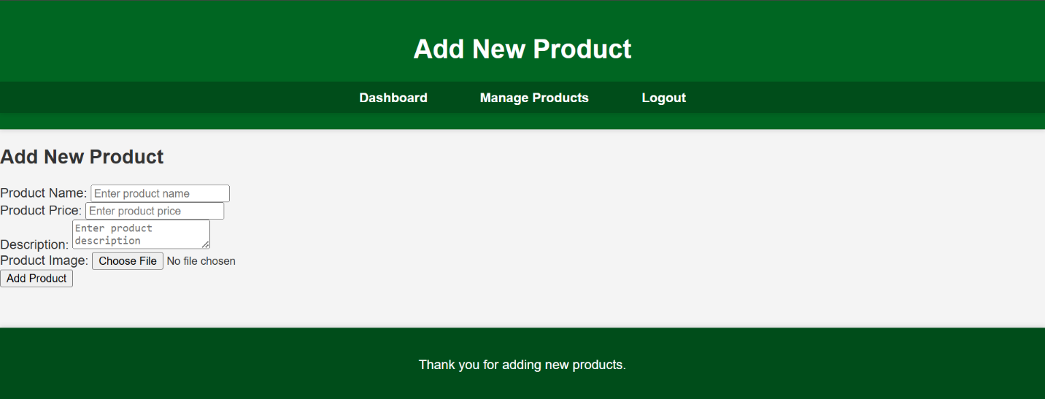
Figure 5.12 Add product Page

CHAPTER-6
BACK-END DESIGN
The back-end design of the garden project focuses on handling server-side logic, database management, and communication between the client and server. It ensures that all data operations are performed efficiently and securely.
6.1 Database Management System Used: MySQL
The database management system employed in the garden project is MySQL, a popular open-source relational database. MySQL is chosen for its robust data management capabilities, ease of use, and compatibility with PHP, the primary server-side language used in your project. It handles the storage, retrieval, and manipulation of all data, including user details, product information, orders, and cart items. The use of MySQL ensures structured data storage using tables and supports SQL queries for efficient data operations.
6.2 Server Environment: PHP
The server environment for the garden project is based on PHP, a widely-used server-side scripting language. PHP is known for its integration with HTML, ease of embedding in web pages, and strong support for building dynamic websites. The PHP environment handles requests from the client, processes user inputs, performs database interactions, and generates responses dynamically. The use of PHP offers flexibility in implementing various functionalities like user authentication, product management, and order processing.
6.3 Frameworks
For this project, there is no specific framework like Laravel (a PHP framework) or other advanced frameworks used. Instead, I have used core PHP functions and features to build the back-end. By using plain PHP without a framework, and maintain direct control over the application's logic and database interactions. While frameworks like Laravel or Symfony can provide additional features and scaffolding, this project focuses on leveraging core PHP to create a straightforward and functional back-end design.
CHAPTER-7
SYSTEM IMPLEMENTATION
The system implementation of the garden project involves setting up the development environment, managing code versions, and ensuring a smooth workflow for building and maintaining the application. This section highlights the tools and systems used in the implementation process.
7.1 Integrated Development Environments (IDEs)
The primary development environment used in this project is Visual Studio Code (VS Code). As a versatile and powerful IDE, VS Code offers a wide range of features such as syntax highlighting, code autocompletion, debugging, and extensions for various programming languages. It provides an intuitive interface and integrates well with web development tools, making it an ideal choice for writing and managing HTML, CSS, JavaScript, and PHP code. Additionally, VS Code's extensions for MySQL and PHP debugging enhance productivity and streamline the coding process.
7.2 Version Control System
The project utilizes Git as the version control system to track code changes and collaborate effectively. Git enables efficient code management by maintaining a history of all modifications, allowing for easy rollbacks to previous versions if needed. With Git, you can branch out new features, merge changes, and resolve conflicts, ensuring a smooth and organized development process. By leveraging Git's capabilities, the project maintains a reliable record of code progress and facilitates collaboration in case of team involvement. The use of GitHub or other Git repositories allows for remote backup and easy sharing of the project code, adding an extra layer of security and accessibility during development.

CHAPTER-8
TESTING AND VALIDATION
8.1 Unit Testing
It is done to check the individual part of the system each module should be separately tested
for errors.
Sl. No | Description | Input | Expected Result | Actual Result | Status
1 | Name field validation during signup | John@123 | Invalid characters | Invalid characters | pass
2 | Name field validation during signup | John | Valid name | Valid name | pass
3 | Email field validation during signup | example.com | Invalid email ID | Invalid email ID | pass
4 | Email field validation during signup | john@gmail.com | Valid email ID | Valid email ID | pass
5 | Password validation during signup | pass | Minimum 8 characters required | Minimum 8 characters required | pass
6 | Password validation during signup | password123 | Valid password | Valid password | pass
7 | Verifying the 'Add to Cart' functionality | Product ID 101 | Product added to cart | Product added to cart | pass
8 | Verifying product quantity in the cart | Quantity: 5 | Quantity updated successfully | Quantity updated successfully | pass
8.2 Integration Testing
Integration testing deals with the handling of interfacing errors, there may arise a lot of chances
for errors at a time of integration.
Sl. No | Description | Input | Expected Result | Actual Result | Status
1 | Adding a product to the cart | Product ID 102 | Product added successfully | Product added successfully | pass
2 | Removing a product from the cart | Product ID 102 | Product removed successfully | Product removed successfully | pass
3 | Updating quantity in the cart | Product ID 101, Qty: 3 | Quantity updated successfully | Quantity updated successfully | pass
4 | Placing an order | Cart details | Order placed successfully | Order placed successfully | pass
5 | Navigating to the checkout page | Cart details present | Redirected to checkout page | Redirected to checkout page | pass
6 | Displaying order summary during checkout | User order details | Order details displayed correctly | Order details displayed correctly | pass
7 | Validating user authentication | Login credentials | Access granted to user pages | Access granted to user pages | pass

8.3 System Testing
System testing is the process of checking if the developed system is working according to the
original objectives and requirements.
Sl. No | Description | Input | Expected Result | Actual Result | Status
1 | Verifying user registration functionality | All required fields | Registration successful | Registration successful | pass
2 | Verifying user login functionality | Correct credentials | Login successful | Login successful | pass
3 | Verifying incorrect login attempts | Incorrect credentials | Login failed, error shown | Login failed, error shown | pass
4 | Verifying product search functionality | Mango | Relevant products displayed | Relevant products displayed | pass
5 | Verifying product details page | Product ID 105 | Product details displayed correctly | Product details displayed correctly | pass
6 | Verifying cart page functionality | Added products | Cart items displayed with details | Cart items displayed with details | pass
7 | Verifying payment method during checkout | Payment details | Payment processed successfully | Payment processed successfully | pass
8 | Verifying order confirmation page | Order ID 302 | Order confirmation displayed | Order confirmation displayed | pass
9 | Verifying logout functionality | Logout clicked | Redirected to login page | Redirected to login page | pass

CHAPTER-9
CONCLUSION
The development of The Garden e-commerce platform has provided a streamlined and accessible solution for plant enthusiasts looking to purchase a variety of plants online. This project involved designing an intuitive user interface, implementing robust back-end functionality using PHP and MySQL, and incorporating essential features like product management, user account handling, and a secure checkout process. Throughout the development, best practices in web development were employed to ensure a seamless and responsive user experience.
9.1 Summary of Work
The project began with identifying the core requirements of the e-commerce platform, focusing on a user-friendly experience for plant purchasing. The front-end was designed using HTML, CSS, and JavaScript to create an attractive and interactive interface. The back-end, developed using PHP, managed user authentication, product listings, and cart functionalities, while MySQL was utilized for efficient data storage and retrieval. The admin dashboard was implemented to facilitate product management, allowing the administrator to add, update, and delete product entries seamlessly. Rigorous testing was performed to validate the application's functionality, ensuring a stable and reliable platform for users.
9.2 Future Scope
There is significant potential for future enhancements to The Garden platform. The website can be expanded by incorporating a wider variety of plant products, including seeds, soil, and gardening tools. Additionally, features like order tracking, customer reviews, and ratings can be implemented to enhance user engagement and satisfaction. Integrating an advanced search and filter option would improve product discoverability. The platform could also benefit from incorporating advanced analytics to provide insights into user behaviour, sales trends, and inventory management. Expanding to a mobile application could further enhance accessibility, allowing users to shop conveniently from their smartphones.

REFERENCES
- PHP & MySQL: Server-Side Web Development :-Ullman, L. Pearson Education, 1st Edition, 2017.
- JavaScript: The Definitive Guide :-Flanagan, D. O'Reilly Media, 7th Edition, 2020.
- HTML & CSS: Design and Build Websites :-Duckett, J. Wiley, 1st Edition, 2011.
- Modern PHP: New Features and Good Practices :-Josh Lockhart. O'Reilly Media, 1st Edition, 2015.
- Learning MySQL :-Seyed Tahaghoghi, S.M., & Williams, H. O'Reilly Media, 2nd Edition, 2007.
- JavaScript and JQuery: Interactive Front-End Web Development :-Duckett, J. Wiley, 1st Edition, 2014.
- AJAX and JSON: Creating Web Applications :-Crane, D., Pascarello, P., & James, D. Peachpit Press, 2nd Edition, 2005
- PHP: www.php.net/docs
- MySQL: dev.mysql.com/doc
- JavaScript (MDN): developer.mozilla.org/en-US/docs/Web/JavaScript
- HTML: developer.mozilla.org/en-US/docs/Web/HTML
- CSS: developer.mozilla.org/en-US/docs/Web/CSS

